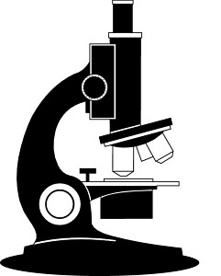
“Microscopes”

Use the information from p.20 – 21 Pearson Skills - Science and Inquiry 1
to complete the following table:

Type of Microscope | Number of lenses | Magnification | Dimension of image
Compound |  | x40 – x1000
Light/Monocular

Binocular |  |  | 2 Dimension
Stereo

Electron | Use a beam of electrons.  3 lenses

Answer the following questions about microscopes and magnification:

1. Calculate the magnification of the following microscopes:

Ocular lens magnification | Objective lens magnification | Total magnification
x10 | x4
x10 | x10
x10 | x40
x10 | x100

2. What is the name of the lens closest to your eye? ____________________________________________

3. What colour images do electron microscopes produce ______________________________________

4. Name one use of stereo microscopes __________________________________________________________

____________________________________________________________________________________________________

